Report on the meeting in Denmark 30/06-04/07/2014

The main issue for our last meeting was writing, discussing and supplementing the EUROPEDIA.
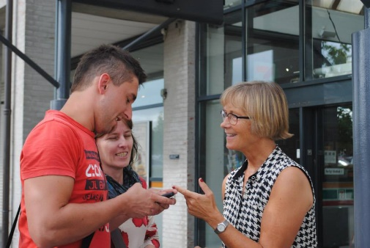
This time the coordinating teachers met without taking any students to be able to concentrate on our final products and intensify our personal relationships which definitely will be prolonged in the future.
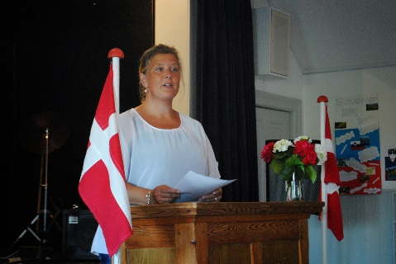
We were very warmly welcomed by our Danish partner school, namely by its Comenius coordinator, Ingrid strandby, on the island of Langeland in the south-west of Copenhagen on Monday afternoon.
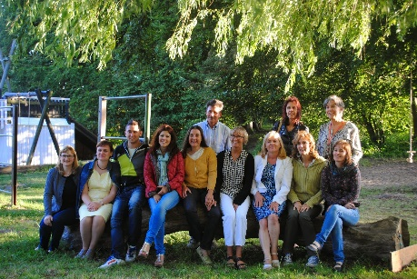
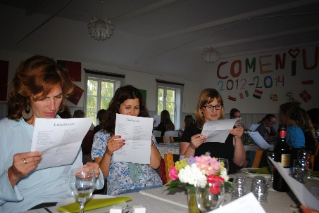
After having checked in, we went to the school Kassebolle Friskole for the welcome dinner, which was delicious, and where the headmistress together with some teachers, parents and students were waiting for us. Besides the headmistress and the coordinator’s welcoming speeches, we sang some traditional Danish songs and the students also performed for the whole audience. Ingrid Strandby, the Danish coordinator, and her colleagues were so kind and gave us an insight into the special philosophy of a Friskole.
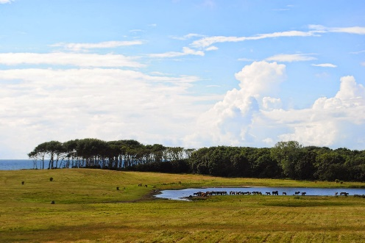
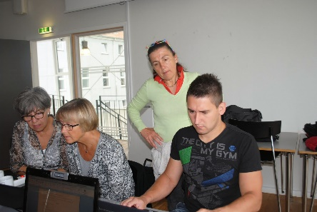
Tuesday started with a working session on our final report. We discussed some ideas and decided on some important points to include in the report, the website and the EUROPEDIA. After that it was time for a delicious lunch eaten outside and with a splendorous view of a lake and its surroundings. In the rest of the afternoon, we could start our visits to some of the country’s heritage sights and had a sightseeing tour to the south of Langeland and could see some wonderful sights, go to the beach, visit a mortuary cave and a horse reserve.
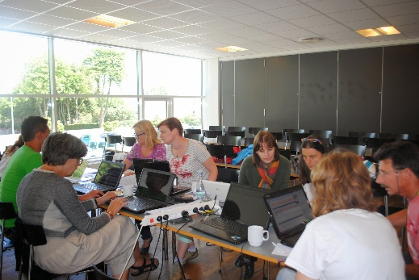
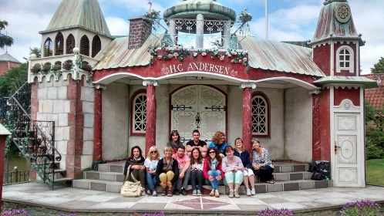
On Wednesday we started the day with a trip to Egeskov Castle and could admire its beautiful gardens and museums and even have lunch there. In the afternoon it was time to visit in Odense the museum of the most worldwide known Danish writer, Hans Christian Andersen. There in the outside we had the opportunity to see a wonderful performance of different fairy tales, some of these fairy tales had been performed by our students in Germany when the Theatre Festival had taken place. But, after this, we still had to work and before dinner we went back to our EUROPEDIA and did some work on it.
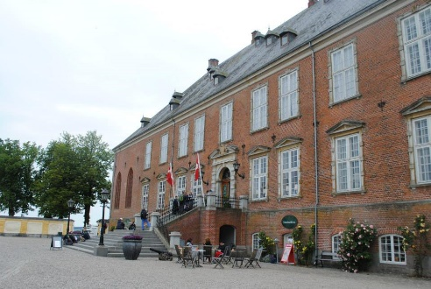
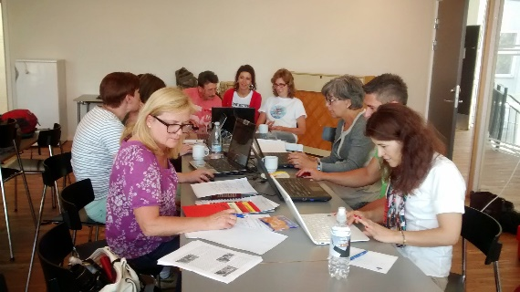
Thursday started with the final working session and at the end our EUROPEDIA was almost done. We agreed on tasks to be done after the meeting and talked about the common products to be uploaded to the EST. We also did a brainstorming on what this project meant to us, teachers, and after a common reflection, we came to the conclusion that it became tremendously important as to: increase knowledge and understanding of other European countries and cultures and way of living, experience an intensive and vivid intercultural exchange, contribute to broaden European citizenship and building on European Dimension, improve communication skills, increase the use of ICT, broaden horizons as to cooperation and collaboration on European grounds, become more tolerant and more open minded, build on a network among participating countries leaving space for future cooperation, make friends for life and overcome boundaries.
In the afternoon we went to Valdemar Castle in Taasinge and after the visit we took the old ferry “Helge” and returned to Svendborg, where we were able to have a look at the city during business hours.
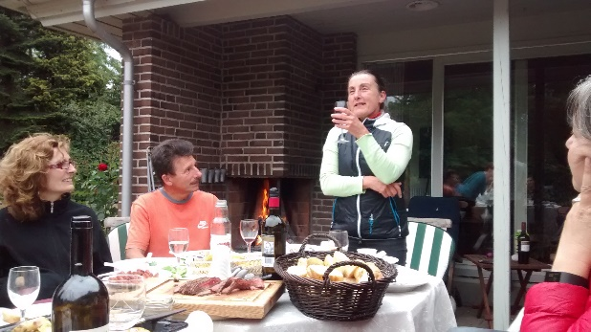
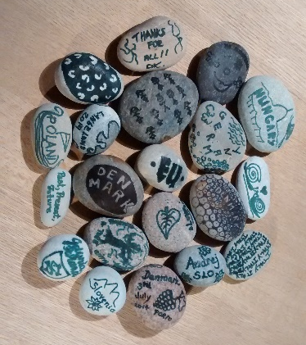
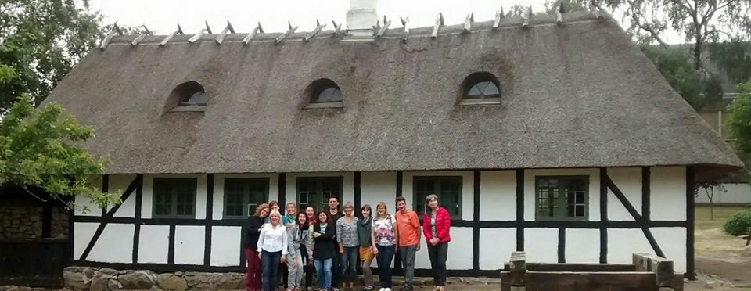
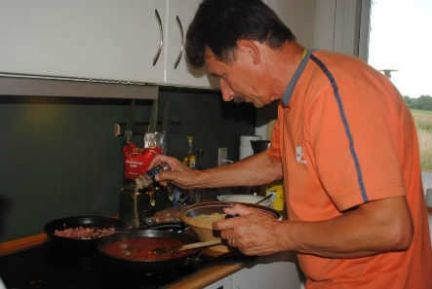
The last dinner together was cooked by some of us at Ingrid Strandby’s place and had as a common objective to share/taste some national traditional dishes/desserts as well as drinks. During the evening, foreign teachers were taken on a cultural tour around Ollerup Gymnastik Höjskole and were introduced to a different kind of school, one that is attended by students more than 18 and who usually want to take a year off to learn about leadership in sports related activities. Before leaving, the German coordinator, as the main one, delivered a speech where she thanked all the collaboration and cooperation among each other and we all came to the conclusion that this project was a very successful one, either for the students as well as for the teachers and the schools.
On Friday we said a very sad goodbye after two amazing years with a lot of new experiences with our fellow partners of this Comenius project:
“European Youth Past, Present, Future. Raising an awareness as to the role every European citizen has got in shaping a common European Future”.

